**Python Script cheet sheet**

**Overview:**

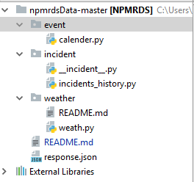

Four python scripts are packaged in this project aims to scrap weath, event and incident data which may have impact on analysis NPMRDS dataset. There are three different packages inside the project, one for weather script, one for incident and another for event.

**Weather Script:**

Location: npmrdsData-master\weather\weath.py

This script can scrap weather data for a specific time period from weather underground api.

This script consists of three functions:

1. Get_history()

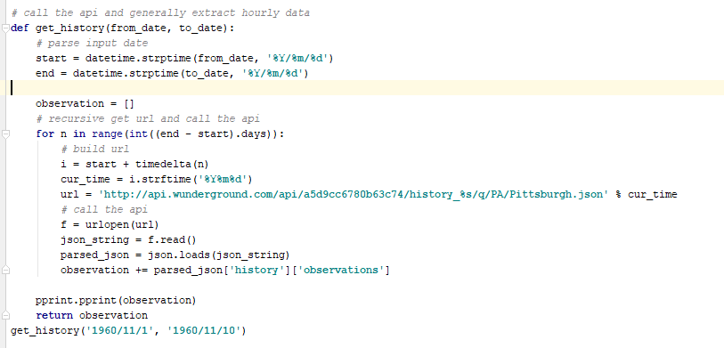

This function aims to get origin data from weatherunderground api, there are two input variables in this function, from_date and to_date, which specify the time period. The format of date would be

”yyyy/mm/dd/”, for example: get_history(‘1960/11/1, ‘1960/11/10’).

1. Parse_result()

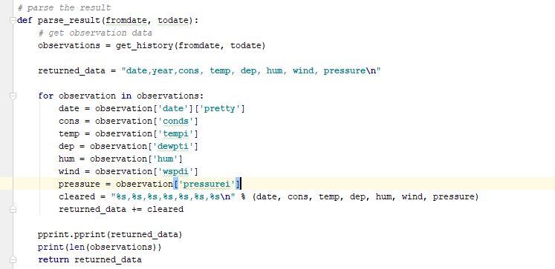

This function aims to parse the origin data the get_history function get from weather underground and also have two date input, the format is same as get_history. This function will call get_history.

1. Save_result()

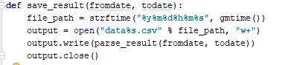

This function is the script’s main function and will call parse_result. The two input has same format with former input.

To use this script:

1. Open weathe.py in PyCharm

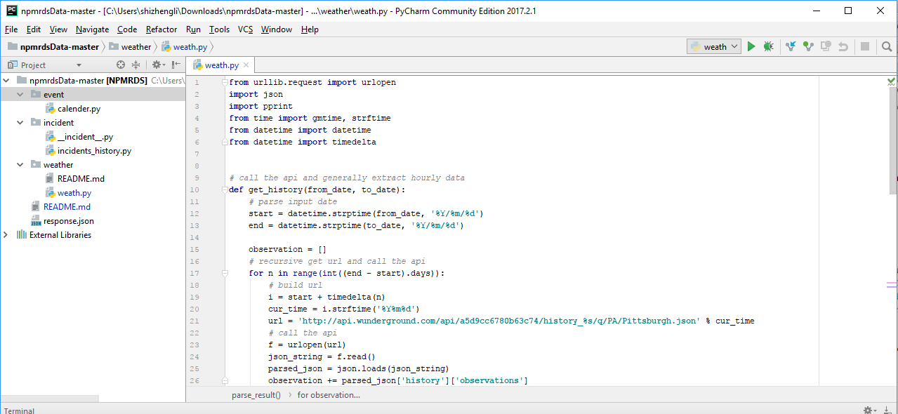

1. Remove “#” in the last line and specify time slot(Call save_ result function)



1. Click “Run” in the top menu



1. Done

**Incident Script**

Location: : npmrdsData-master\incident\ __incident__.py

This script aims to scrap real-time incident information from PA-511 database.

The script only have on function get_json since the api will return data in json format

get_json():

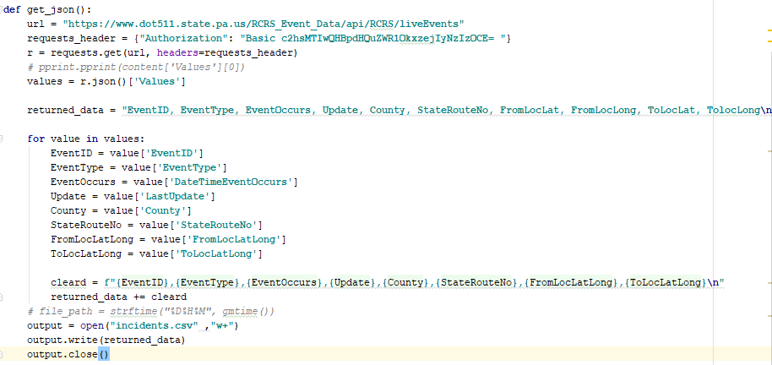

To use this script:

1. Open script in pycharm

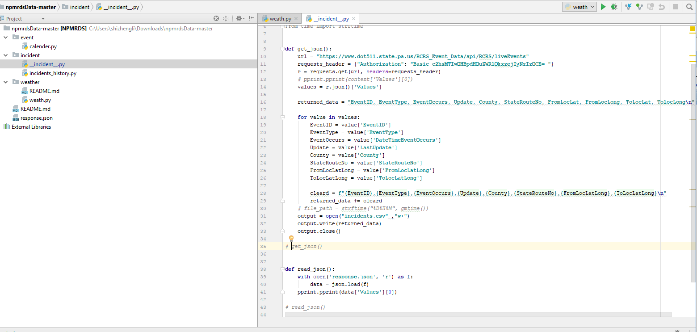

2．Remove “#” before get_json()



1. click “Run”



1. done

**Events Calender Script:**

Location: npmrdsData-master\event\calender.py

This script aims to scrap pittsburgh’s three main stadium events. There are three functions in this script.

Get_ppg(): get ppg arena’s event

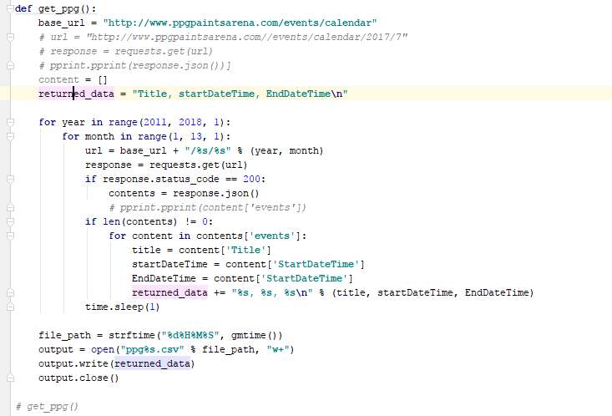

Get_pirates(): get pirates calendar

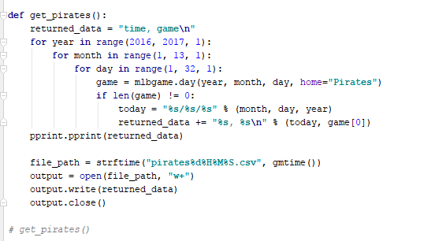

Get_field(): get Heinz field’s event calender

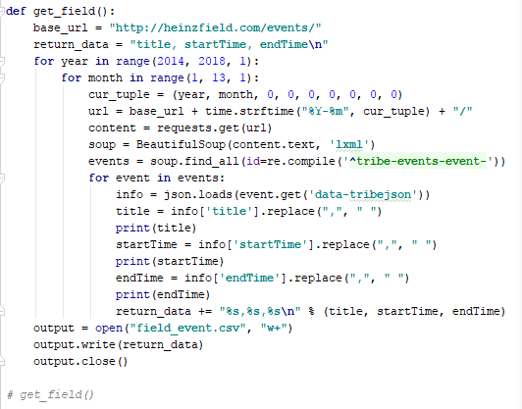

To use this script:

1. open script in pycharm

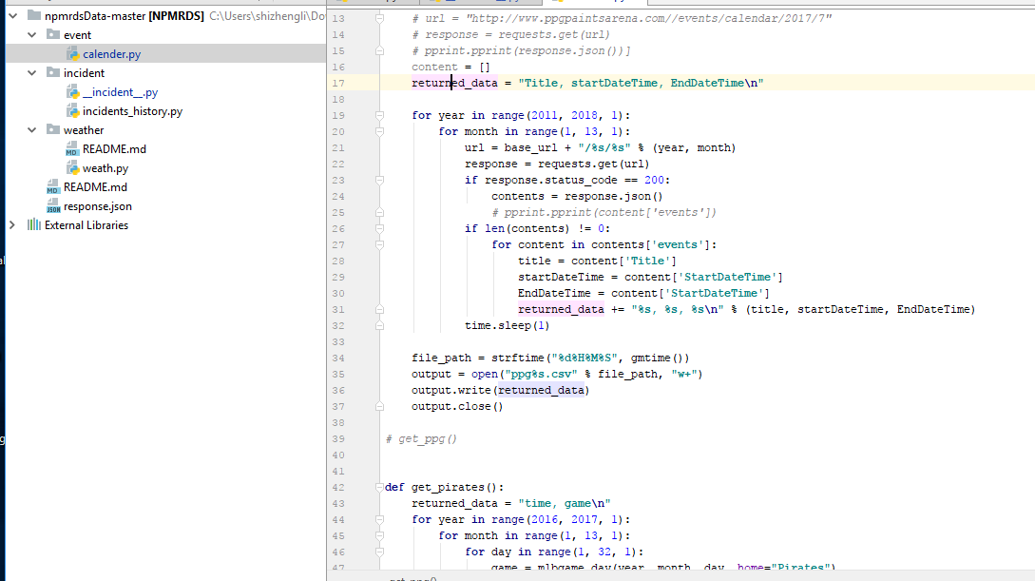

1. locate time range in for loop

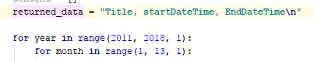

1. specify the time period
2. remove “#” before the method you want to run



1. click “run”

